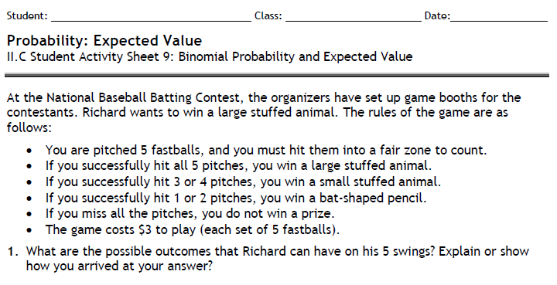

a. All 5 pitches? b. 4 pitches? c. 3 pitches? d. 2 pitches? e. 1 pitch? f. 0 pitches?
3. Suppose Richard tries the game 100 times. How many times do you expect him to successfully hit the given amounts of times below? Show your work.
a. All 5 pitches?
b. 4 pitches?
c. 3 pitches?
d. 2 pitches?
e. 1 pitch?
f. 0 pitches?

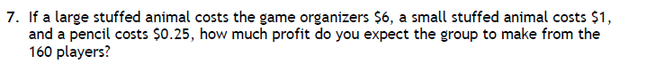
Ticket Revenue: | $3 per play |  |  | _______________
Less Cost of Prizes: | Large Animal | ____________________ |  | _______________
 | Small Animal | ____________________
 | Pencil | ____________________
Net Income: |  |  |  | _______________

