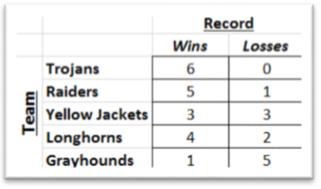 Convert each table into an appropriate matrix.

1. 2. 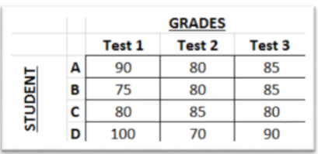

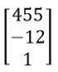Determine the dimensions of each matrix.

3.  4. 5. 6.

Perform the indicated operation, if possible. If not possible, state the reason.

7.  8. 

9.  10. 

11.  12. 

13.  14. 

15. 16.

Solve the matrix equation for *x* and *y*.

17.  18. 

19.  20. 

Give an example of each type of matrix.

21. Number (1x1) Matrix 22. Square matrix with 9 entries

23. Zero matrix with 4 entries 24. Square matrix with 4 entries and 1’s down the main

diagonal and zeros everywhere else

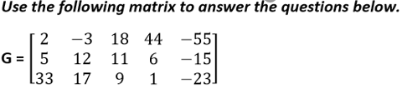

25. The name of the matrix is ________________

26. The dimensions of the matrix are ___________.

27. g23 = _________

28. g51 = _________

29. The address of the number 17 is ____________.